Project Development –Delivery of Sprint 2

**Creating Node –Red service and connect with IBM cloud and Web UI**

|  |  |
| --- | --- |
| **TITLE** | IOT based child safety gadget for child safety monitoring and notification |
| **TEAM ID** | PNT2022TMID44407 |

**Creating Node-Red service:**

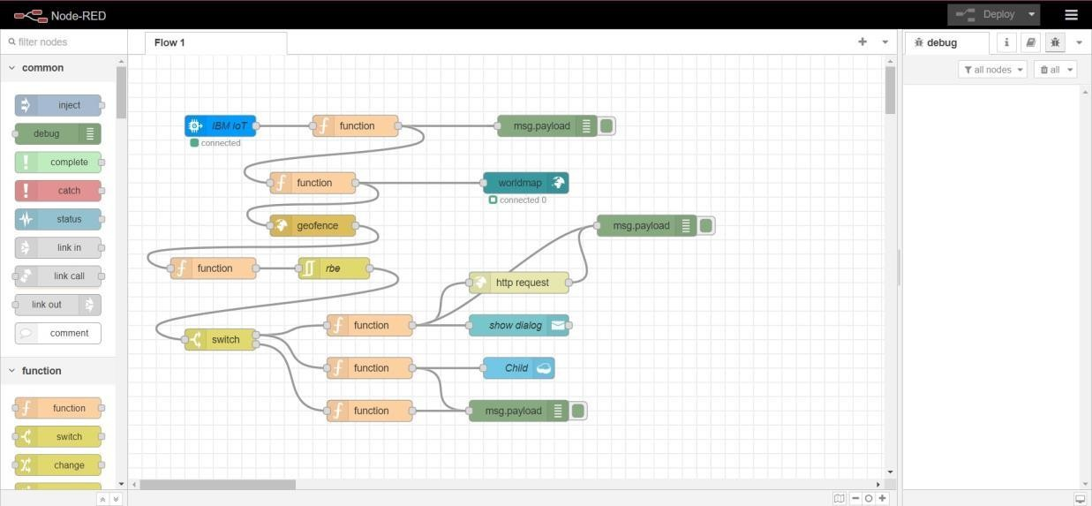

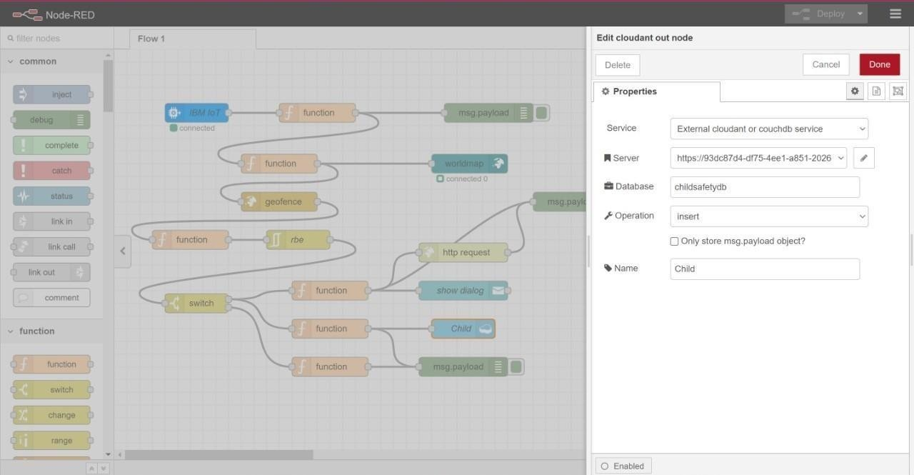

Connecting with IBM Cloud:

Using IBM IOT node through API key

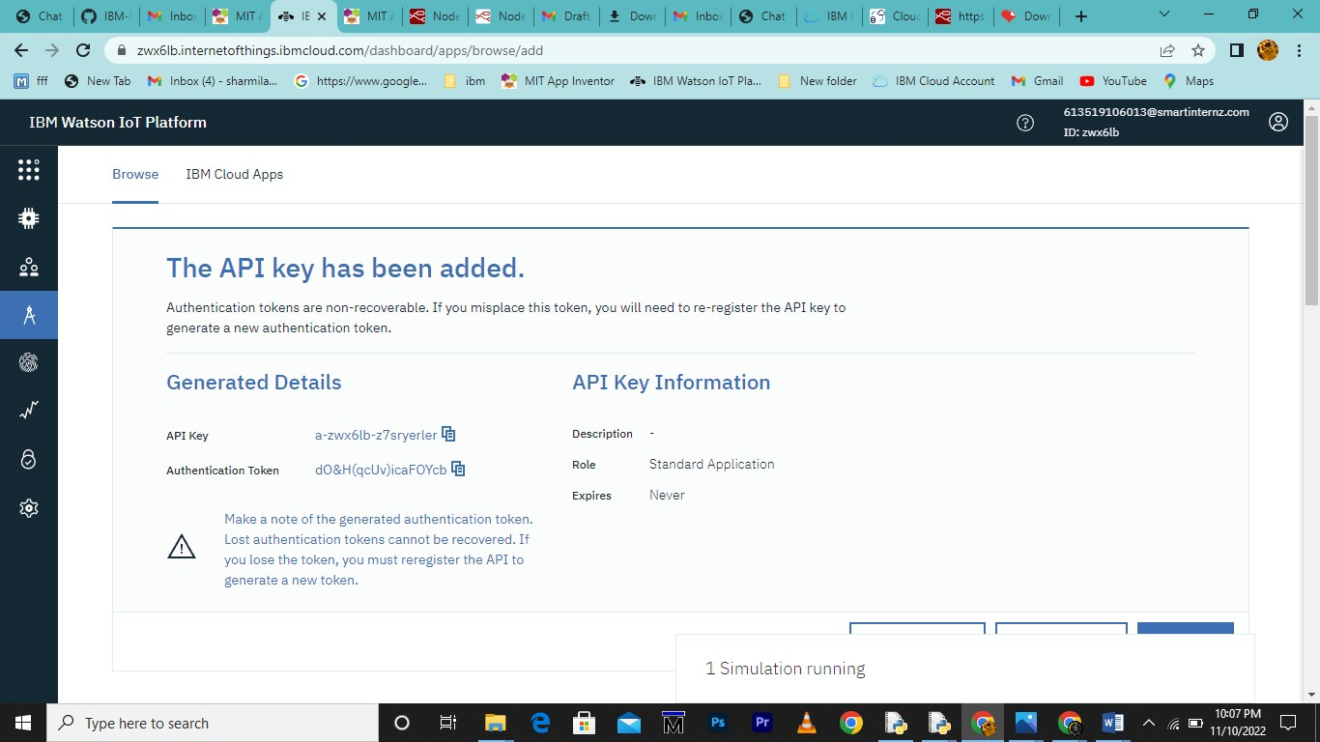

Transfering values from Python Code:

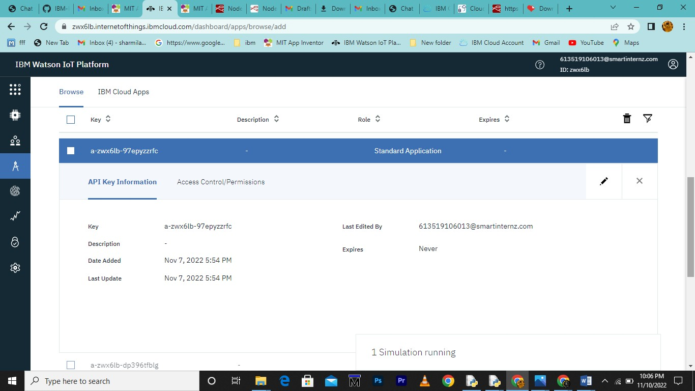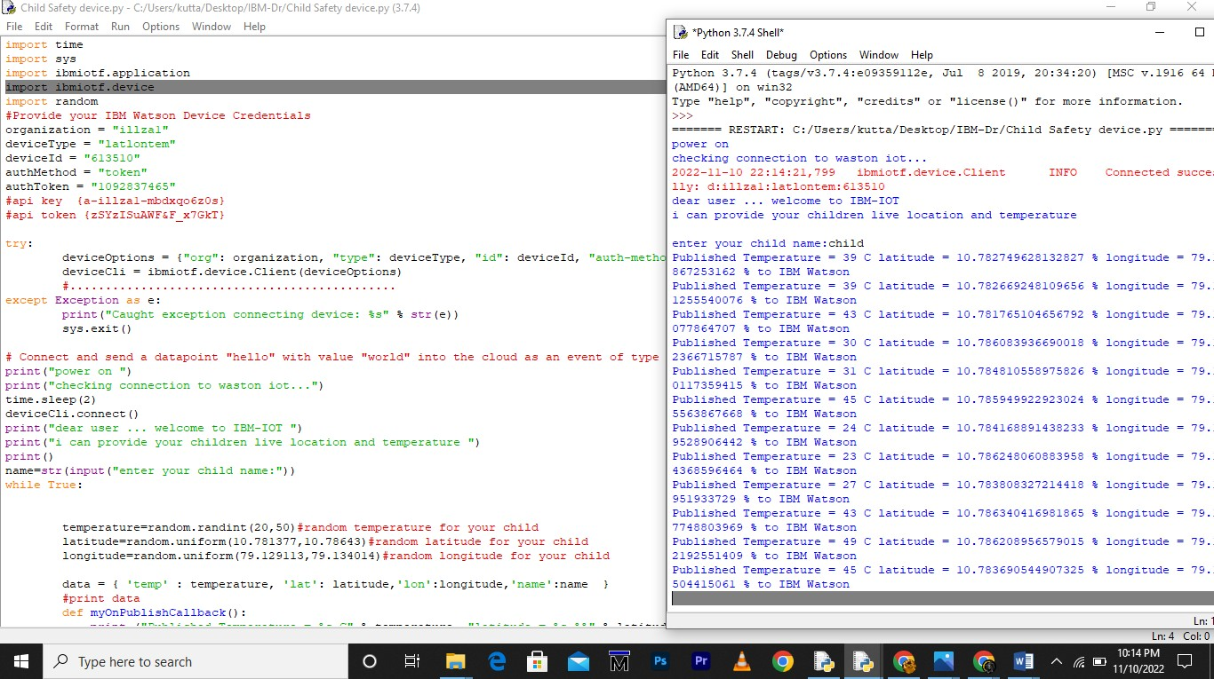

Node-Red:

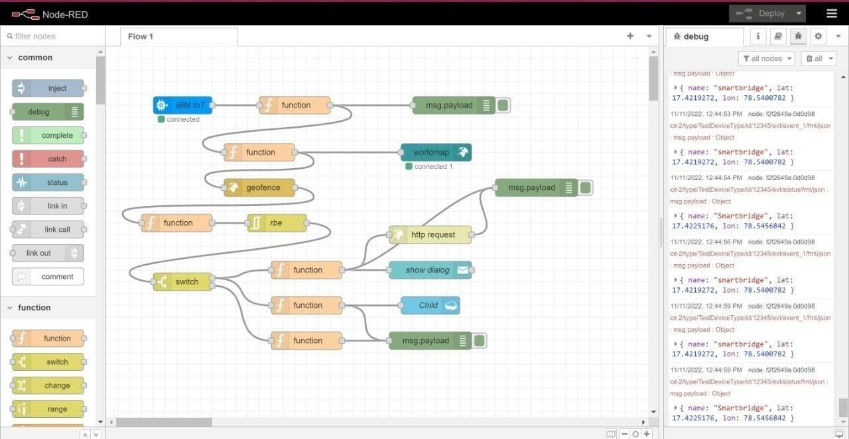

Node-Red Dashboard:

